Hierarchical Task Framing for Prevention-Oriented Cervical Lesion Detection

Using Nigerian Colposcopy Images

Anonymized Authors
Anonymized Affiliations
email@anonymized.com

Abstract. Cervical cancer progresses through a precancerous stage that, if detected early, can be treated before invasive carcinoma develops. However, most deep learning approaches to colposcopy-based screening frame the problem as binary: normal-versus-abnormal or cancer-versus-non-cancer classification, overlooking the precancerous class that is most actionable for prevention. Whether task framing affects the accurate de-tection of precancerous lesions remains underexplored. We present a hi-erarchical task framing for cervical lesion grading that decomposes the problem into a cascade of clinically motivated binary decisions. We com-pare this against conventional 4-class and 3-class task framings to in-vestigate which best supports precancerous detection. Experiments are conducted on a Nigerian colposcopy screening dataset comprising 2,835 images from 282 patients, labelled across four clinically grounded sever-ity grades: Normal, Borderline, Low-grade Precancerous, and High-grade Precancerous. Two deep learning architectures are evaluated across all three task framings under strict patient-level splits. Results show that the hierarchical task framing consistently achieves higher macro-recall across all stages compared to the 4-class and 3-class task framings, with the best hierarchical stage reaching a macro-recall of 0.592, versus 0.272 and 0.365 for the 4-class and 3-class task framings respectively. These findings suggest that hierarchical task framing offers a more effective and prevention-oriented approach for cervical cancer triage in resource-constrained settings.

Keywords: Cervical Cancer · Colposcopy Image · Hierarchical Classi-fication

Introduction
Cervical cancer is the fourth most common cancer in women globally, with over 94% of deaths occurring in low- and middle-income countries (LMICs) where ac-cess to trained colposcopists is severely limited [20, 3]. Cervical cancer progresses through a precancerous stage that, if detected early, can be treated before in-vasive carcinoma develops [1, 14]. This makes precancerous detection the most clinically actionable target for prevention-oriented screening. In LMICs such as

Nigeria, the shortage of specialist clinicians, inadequate vaccination coverage, and disparities in healthcare infrastructure further limit timely diagnosis and management [16, 13].
Deep learning has emerged as a promising tool for automating colposcopy-based cervical lesion detection, with several approaches demonstrating encourag-ing results [6, 4, 8]. However, most existing methods frame the problem as binary normal-versus-abnormal or cancer-versus-non-cancer classification, or broad multi-class schemes [5, 18]. These task framings collapse or overlook the precancerous class, the category that is most important for prevention, making it difficult to assess whether a model is clinically safe for triage. Whether task framing itself affects the accurate detection of precancerous lesions remains underexplored.
Here, we present a hierarchical task framing for cervical lesion grading that decomposes the classification problem into a cascade of three clinically moti-vated binary decisions. We evaluate this against conventional 4-class and 3-class task framings using two deep learning architectures on a Nigerian colposcopy screening dataset [15] of 2,835 images from 282 patients, collected at Bowen University Teaching Hospital, city, country, under institutional ethical approval. Results show that the hierarchical task framing consistently achieves higher macro-recall for precancerous lesions across all stages compared to the 4-class and 3-class task framings.
Our main contributions are:
- We present a hierarchical task framing for colposcopy-based cervical lesion grading that decomposes the problem into three clinically motivated binary decision stages, explicitly preserving the precancerous class.
- We provide a systematic comparison of three task framings: hierarchical, 4-class, and 3-class, across two deep learning architectures under strict patient-level splits, demonstrating that hierarchical task framing consistently achieves higher macro-recall than the 4-class and 3-class task framings and contribut-ing evidence for prevention-oriented cervical lesion detection in an LMIC context where such evaluations remain scarce.

Related Work

Deep Learning for Colposcopy-Based Cervical Lesion Detection
Deep learning has been widely applied to colposcopy image analysis, with sev-eral studies demonstrating competitive diagnostic accuracy. Fine-tuned ResNet architectures on colposcopic photographs have reported four-class accuracy of 74.7% under the Lower Anogenital Squamous Terminology (LAST) grading system and an AUC of 0.781 for discriminating high-risk from low-risk lesions [5]. Incorporating acetowhite epithelium segmen-tation as an additional input channel improved binary high-grade squamous intraepithelial lesion (HSIL) detection to 76.3% accuracy, a gain of over 10 percentage points compared to image-only classi-fication [8]. Combining acetic acid and iodine colposcopy images with clinical features including HPV status and cytology results yielded an AUC of 0.93 for binary lesion classification [21]. Fusing three sequential image types per patient

using EfficientNet-B0 and a GRU achieved 91.18% three-class accuracy [4], and combining Swin Transformer feature extraction with a deep learning ensem-ble further demonstrated the benefit of transformer-based representations for colposcopic classification [6]. Despite these advances, a systematic review and meta-analysis confirmed that high-grade lesion detection remains the weakest point across published methods [11], motivating the task framing investigation in this work.

Classification Framework Design and Task Framing

How the classification problem is framed directly shapes what a model learns and which lesions it misses. Binary formulations: normal versus abnormal or can-cer versus non-cancer, typically achieve higher aggregate accuracy than multi-class schemes because the decision boundary is simpler, but they collapse the precancerous class that is most actionable for prevention [18, 5]. Broader multi-class schemes preserve more clinical granularity but increase confusion between adjacent grades. It has been demonstrated for gastric cancer staging that dif-ferent class granularities produce materially different error profiles on the same dataset, establishing that task framing, not architecture alone, determines which lesions are missed [10]. Hierarchical pipelines offer a clinically motivated alterna-tive by decomposing the problem into a cascade of binary decisions that mirror clinical reasoning. Hierarchical medical image classification has been shown to outperform multi-class approaches on biopsy images [9], and similar gains have been reported for ophthalmic disease classification under limited training data, suggesting that hierarchical framing eases class imbalance by focusing model capacity on one decision at a time [2]. However, no study has systematically compared hierarchical, 4-class, and 3-class task framings on colposcopy images with precancerous recall as the primary outcome.

Class Imbalance and High-Grade Lesion Detection

High-grade precancerous lesions are systematically underrepresented in colposcopy datasets, causing models trained on standard loss functions to over-predict the majority class [18, 7]. The clinical cost of this imbalance is asymmetric. A missed HSIL may progress to invasive car-cinoma, whereas an unnecessary referral results only in an additional biopsy. Despite this, most published studies report overall accuracy or AUC as primary metrics, obscuring per-class recall and making it difficult to assess model safety for the most critical diagnostic category [11, 17]. By adopting macro-recall as the primary evaluation metric and preserving the precancerous class explicitly across all three task framings, this study addresses a gap that aggregate metrics systematically conceal.

Methodology

Dataset

The Bowen University AI-assisted Cervical Cancer Screening Dataset [15] com-prises 3,356 high-resolution colposcopy images from 332 women screened at Bowen University Teaching Hospital, Ogbomoso, Nigeria. Images were captured at four magnification levels (1×, 3×, 5×, 7×) before and after application of 5% acetic acid, yielding up to eight views per patient. The dataset provides binary labels (Normal/Abnormal); raw cytology text from per-patient .txt files is nor-malised and mapped to a four-class severity hierarchy aligned with the LAST grading system: Normal (NILM, re-active), Borderline (ASCUS), Low-grade Precancerous (LSIL/CIN1), and High-grade Precancerous (HSIL/CIN2-3). Following data cleaning — exclud-ing patients with inadequate labels, ASCUS in the normal folder, or non-lesion abnormal labels — 2,835 images from 282 patients are retained. The dataset is imbalanced: Normal (62.1%), Low-grade Precancerous (14.9%), Borderline (13.1%), and High-grade Precancerous (9.9%). Images were resized to 224 × 224 pixels, normalised using ImageNet statistics, and preprocessed with Wiener fil-tering, specular reflection removal, and colour normalisation.

Task Framing

We present a hierarchical task framing that decomposes cervical lesion grad-ing into a cascade of three clinically motivated binary decisions, each trained independently on the relevant patient subset:

    - Stage 1: Normal vs. Abnormal (all 282 patients)
    - Stage 2: Borderline vs. Precancerous (abnormal patients only)
    - Stage 3: Low-grade vs. High-grade Precancerous (precancerous patients only)

This cascade mirrors the sequential reasoning of a colposcopist, first flagging abnormality, then grading severity, then differentiating precancerous grade. By isolating each decision, the hierarchical framing explicitly preserves the precan-cerous class at every stage. Two conventional task framings serve as baselines: a 4-class framing classifying all four grades simultaneously, and a 3-class framing collapsing the two precancerous grades into a single Precancerous class.

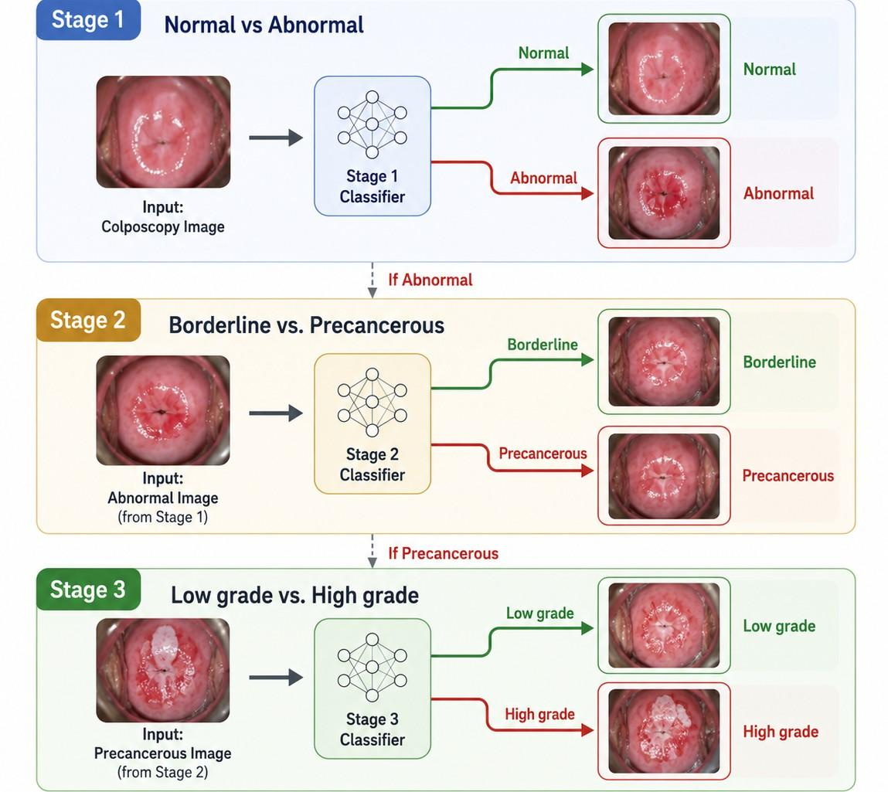

Fig. 1. The three-stage hierarchical task framing.

Model Architectures
Both pipelines share a Swin Transformer (Swin-T) [12] pretrained on ImageNet as a shared feature extraction backbone, producing 768-dimensional represen-tations offline prior to classifier training [6]. The two pipelines differ in their classification heads.
Pipeline A - EfficientNet-B3. Swin-T features are passed to an EfficientNet-B3 [19] backbone with its classifier replaced by a two-layer MLP (Linear → BN
→ ReLU → Dropout → Linear(C)). The backbone is initially frozen, with the final two blocks unfrozen after epoch five.
Pipeline B - LSTEDL-CCS Ensemble. Following [6], Swin-T features are processed in parallel by an Autoencoder (AE, 768→640→512), a Bidirectional
GRU (BiGRU, hidden dim 256), and a Deep Belief Network (DBN, sizes [512, 256, 128]). Their outputs (896 dimensions total) are concatenated and passed through a fu-
sion classifier to produce the final prediction.

Training Strategy
All models train for up to 50 epochs with early stopping on validation macro-recall (patience 10, min delta 10⁻⁴), AdamW optimiser (lr = 10⁻⁴, weight decay 10⁻³), OneCycleLR scheduling, focal loss (γ = 1.0, label smoothing 0.1), and class-weighted sampling. Dataset splits are 70/15/15 at patient level using strat-ified sampling, with WeightedRandomSampler applied to training loaders. The primary metric is macro-averaged recall; secondary metrics are macro-precision, macro-F1, accuracy, and macro-specificity.
Compute resources. All experiments are conducted on a single NVIDIA A100 GPU (40GB VRAM) on the Alliance Canada Narval HPC cluster, with a fixed random seed of 42 for reproducibility. Swin-T feature extraction is performed

once per split offline. EfficientNet-B3 models converge in 10–20 epochs; ensemble classifier training on pre-extracted features converges in under 5 minutes. End-to-end inference for Pipeline A takes approximately 163ms per image; Pipeline B runs at under 2ms per image on pre-extracted features

Results

Evaluation Metrics
Given the clinical context of cervical cancer screening, macro-recall (sensitivity) is designated as the primary optimisation target. A missed high-grade lesion carries far greater consequences than a false positive that triggers follow-up investigation, so model selection and early stopping during training are governed exclusively by validation macro-recall. Formally, macro-recall is computed as the unweighted mean of per-class recall:

Macro − Recall = ¹
K
Σ
k=1
K
TP_{k} TP_{k} + FN_{k}

(1)
where K is the number of classes and TP_{k} and FN_{k} denote true positives and false negatives for class k. Unweighted averaging gives equal weight to each class regardless of support size, which matters because High-grade Precancer-ous lesions are substantially outnumbered by Normal cases. Secondary metrics reported include overall accuracy, macro-precision, and macro-F1. For the hier-archical pipeline, each stage is evaluated independently on its patient subset.

Experiments and Results

Table 1. Test-set performance across task framings and model architectures. Macro-recall is the primary metric.

Pipeline Task Classes Accuracy Macro-P Macro-R Macro-F1
EfficientNet 4-class | 4 | 0.400 | 0.272 | 0.272 | 0.259
Ensemble 4-class | 4 | 0.120 | 0.243 | 0.246 | 0.110
EfficientNet 3-class | 3 | 0.414 | 0.346 | 0.365 | 0.319
Ensemble 3-class | 3 | 0.286 | 0.326 | 0.318 | 0.255
EfficientNet Hier. Stage 1 | 2 | 0.587 | 0.554 | 0.554 | 0.554
EfficientNet Hier. Stage 2 | 2 | 0.533 | 0.582 | 0.592 | 0.530
EfficientNet Hier. Stage 3 | 2 | 0.504 | 0.533 | 0.534 | 0.504
Ensemble Hier. Stage 1 | 2 | 0.553 | 0.544 | 0.547 | 0.540
Ensemble Hier. Stage 2 | 2 | 0.509 | 0.562 | 0.569 | 0.506
Ensemble Hier. Stage 3 | 2 | 0.374 | 0.684 | 0.507 | 0.283

4-class and 3-class Task Framings. Under the 4-class framing, EfficientNet-B3 achieved a macro-recall of 0.272; the ensemble performed substantially worse (0.246) and produced zero predictions for the Borderline category, a near-complete failure attributable to class imbalance. Collapsing the two precancerous grades under the 3-class framing improved EfficientNet-B3 macro-recall to 0.365, as the merged class carries greater support and a broader visual footprint. However, Borderline precision of 0.194 indicates a tendency to over-predict this class. The ensemble remained well below EfficientNet under both framings.

Hierarchical Task Framing. The hierarchical task framing consistently out-performed the 4-class and 3-class task framings across the primary metric. EfficientNet-B3 achieved its highest accuracy at Stage 1 (0.587) and its highest macro-recall at Stage 2 (0.592), suggesting that the Borderline versus Precancerous distinction
is more reliably captured than finer-grained decisions. Stage 3 (Low-grade vs. High-grade Precancerous) was the weakest point for both models: EfficientNet-B3 achieved a macro-recall of 0.534, barely above chance, and the ensemble showed an extreme precision–recall imbalance (macro-precision 0.684, macro-F1 0.283), indicating it defaulted to one class rather than discriminating between the two precancerous grades. Both models exceeded their respective 4-class ac-curacies across the hierarchical stages.

End-to-End Hierarchical Pipeline Estimate. To situate the hierarchical results within a single comparable figure, an approximate end-to-end accuracy is derived by chaining stage-wise macro-recalls across the test-set class distribution (285 Normal, 50 Borderline, 73 Low-grade, 42 High-grade; n = 450):
A^{ˆ} = r₁ · p_{N} + r₁ · r₂ · (p_{B} + p_{P} ) + r₁ · r₂ · r₃ · (p_{L} + p_{H} ) (2)
where r₁, r₂, r₃ are stage macro-recalls and p_{N} , p_{B}, p_{L}, p_{H} are the propor-tions of Normal, Borderline, Low-grade, and High-grade images in the test set. This formulation assumes stage independence and should be understood as an approximation rather than an exact figure. Under this formulation, EfficientNet achieves an estimated end-to-end accuracy of approximately 0.43, compared with
0.42 for the ensemble, both exceeding the 4-class accuracy for their respective model families (0.400 and 0.120).

Discussion
The results suggest that, under this experimental setting, task framing mean-ingfully influences precancerous detection. Decomposing the four-class grading problem into a cascade of binary decisions consistently raised macro-recall above either the 4-class or 3-class task framing on the same limited dataset. This improvement is largely structural. Each stage resolves one well-defined distinc-tion at a time, reducing inter-class confusion. Whether this pattern holds across larger, more diverse datasets remains an open question. Stage 3 (Low-grade vs.

High-grade Precancerous) warrants careful interpretation. Both models showed marginal discrimination, with macro-recall of 0.534 for EfficientNet-B3 and 0.507 for the ensemble, but the nature of this failure differs. EfficientNet-B3’s preci-sion and recall are relatively balanced, suggesting symmetric uncertainty be-tween the two grades. The ensemble, by contrast, shows a macro-precision of 0.684 alongside a macro-F1 of 0.283, indicating it defaults to one class rather than discriminating. Both outcomes are consistent with the same underlying cause: the boundary between low-grade and high-grade dysplasia on colposcopy is subtle and is conventionally confirmed histologically rather than visually, sug-gesting this limitation reflects genuine visual ambiguity rather than a correctable modelling failure alone.

Limitations. The dataset is drawn from a single institution using a single colposcopy device, limiting generalisability across clinical sites and equipment types. Labels derive from colposcopic images and cytology reports rather than histopathological biopsy confirmation, introducing label noise precisely at the Low-grade versus High-grade boundary where both models struggle most. Class definitions also vary across studies, some collapse borderline and low-grade le-sions, others use binary endpoints, making direct numerical comparison with published results unreliable.

Impact in Resource-Constrained Settings

The proposed pipeline is designed with LMIC deployment in mind. Swin-T fea-ture extraction is performed offline as a one-time preprocessing step, decou-pling computational cost from real-time inference. Pipeline B classifiers then run at under 2ms per image without GPU access, making them deployable on standard clinical hardware. The hierarchical framing further supports resource-constrained deployment through early termination: a Stage 1 Normal prediction requires no further computation, reserving resources for abnormal cases requiring grading. Strict patient-level evaluation provides a realistic performance estimate on new patients in comparable settings.

Conclusion

This study presents a hierarchical task framing for cervical lesion grading and compares it against 4-class and 3-class task framings on a Nigerian colposcopy dataset under strict patient-level splits. The hierarchical task framing consis-tently achieves higher macro-recall across all stages under this setting, and EfficientNet-B3 outperforms the ensemble throughout. However, Low-grade vs. High-grade Precancerous discrimination at Stage 3 remains poor for both models with macro-recall of 0.534 for EfficientNet-B3 and 0.507 for the ensemble, reflect-ing both visual ambiguity in the colposcopic modality and potential label noise at this boundary, identifying this as the critical bottleneck for prevention-oriented

cervical cancer triage. Future work should target this boundary through his-tologically confirmed labels, multimodal fusion incorporating HPV typing, and validation across multiple clinical sites and device types.

References
- Allogmani, A., Mohamed, R., Al-Shibly, N., Ragab, M.: Enhanced cervi-cal precancerous lesions detection and classification using Archimedes op-timization algorithm with transfer learning. Scientific Reports 14 (2024). https://doi.org/10.1038/s41598-024-62773-x
- An, G., Akiba, M., Omodaka, K., Nakazawa, T., Yokota, H.: Hierarchical deep learning models using transfer learning for disease detection and classification based on small number of medical images. Scientific Reports 11(1) (2021). https://doi.org/10.1038/s41598-021-83503-7
- Bray, F., Laversanne, M., Sung, H., Ferlay, J., Siegel, R., Soerjomataram, I., Jemal, A.: Global cancer statistics 2022: GLOBOCAN estimates of incidence and mortal-ity worldwide for 36 cancers in 185 countries. CA: A Cancer Journal for Clinicians 74(3), 229–263 (2024). https://doi.org/10.3322/caac.21834
- Chen, X., Pu, X., Chen, Z., Li, L., Zhao, K., Liu, H., Zhu, H.: Application of EfficientNet-B0 and GRU-based deep learning on classifying the colposcopy di-agnosis of precancerous cervical lesions. Cancer Medicine 12, 8690–8699 (2023). https://doi.org/10.1002/cam4.5581
- Cho, B., Choi, Y., Lee, M., Kim, J., Son, G., Park, S., et al.: Classification of cervi-cal neoplasms on colposcopic photography using deep learning. Scientific Reports 10, 13652 (2020). https://doi.org/10.1038/s41598-020-70490-4
- Himabindu, D., Lydia, E., Rajesh, M., Ahmed, M., Ishak, M.: Leverag-ing Swin transformer with ensemble of deep learning models for cervi-cal cancer screening using colposcopy images. Scientific Reports 15 (2025). https://doi.org/10.1038/s41598-025-90415-3
- Kaur, H., Sharma, R., Kaur, J.: Comparison of deep transfer learning models for classification of cervical cancer from pap smear images. Scientific Reports 15 (2025). https://doi.org/10.1038/s41598-024-74531-0
- Kim, J., Park, C., Kim, S., Cho, A.: Convolutional neural network-based classification of cervical intraepithelial neoplasias using colposcopic image seg-mentation for acetowhite epithelium. Scientific Reports 12, 17228 (2022). https://doi.org/10.1038/s41598-022-21692-5
- Kowsari, K., Sali, R., Ehsan, L., Adorno, W., Ali, A., Moore, S., Amadi, B., Kelly, P., Syed, S., Brown, D.: HMIC: Hierarchical medical image classification, a deep learning approach. Information 11(6), 318 (2020). https://doi.org/10.3390/info11060318
- Lima, G., Coimbra, M., Dinis-Ribeiro, M., Libanio, D., Renna, F.: Analysis of classification tradeoff in deep learning for gastric cancer detection pp. 2177–2180 (2022). https://doi.org/10.1109/embc48229.2022.9871040
- Liu, L., Liu, J., Su, Q., Chu, Y., Xia, H., Xu, R.: Performance of artificial in-telligence for diagnosing cervical intraepithelial neoplasia and cervical cancer: a systematic review and meta-analysis. EClinicalMedicine 80, 102992 (2024). https://doi.org/10.1016/j.eclinm.2024.102992
- Liu, Z., Lin, Y., Cao, Y., Hu, H., Wei, Y., Zhang, Z., Lin, S., Guo, B.: Swin trans-former: Hierarchical vision transformer using shifted windows. In: Proceedings of

the IEEE/CVF International Conference on Computer Vision (ICCV). pp. 10012–10022 (2021)
- Mafiana, J.J., Dhital, S., Halabia, M., Wang, X.: Barriers to uptake of cervical cancer screening among women in Nigeria: a systematic review. African Health Sciences 22(2), 295–309 (2022). https://doi.org/10.4314/ahs.v22i2.33
- Mathivanan, S., Francis, D., Srinivasan, S., Khatavkar, V., P, K., Shah, M.: En-hancing cervical cancer detection and robust classification through a fusion of deep learning models. Scientific Reports 14 (2024). https://doi.org/10.1038/s41598-024-61063-w
- Ogunlaja, A.O., Adeleke, O.T., Ughonu, P.C., Oyelami, M.O., Ano-Edward, G.,
Bakare, Y.T., Bobo, I.T., Atanda, G.O., Oyebade, I.A., Afolabi, A.O., Adeniji, O.D., Bello, G.O., Okunoye, O.O., Ladoye, O.O.: A multi-magnification digital colposcopy image datasets for cervical cancer screening in Nigeria. Data in Brief 65, 112633 (Apr 2026). https://doi.org/10.1016/j.dib.2026.112633, pMID: 41852843; PMCID: PMC12992497
- Ola, O., Okunowo, A., Habeebu, M., Miao Jonasson, J.: Clinical and non-clinical determinants of cervical cancer mortality: A retrospective co-hort study in Lagos, Nigeria. Frontiers in Oncology 13, 1105649 (2023). https://doi.org/10.3389/fonc.2023.1105649
- Qin, D., Bai, A., Xue, P., Seery, S., Wang, J., Mendez, M., Li, Q., Jiang, Y., Qiao, Y.: Colposcopic accuracy in diagnosing squamous intraepithelial lesions: a systematic review and meta-analysis of the IFCPC 2011 terminology. BMC Cancer 23(1), 187 (2023). https://doi.org/10.1186/s12885-023-10648-1
- Sarhangi, H., Beigifard, D., Farmani, E., Bolhasani, H.: Deep learning techniques for cervical cancer diagnosis based on pathology and colposcopy images. arXiv abs/2310.16662 (2023). https://doi.org/10.48550/arxiv.2310.16662
- Tan, M., Le, Q.: EfficientNet: Rethinking model scaling for convolutional neural networks. In: Proceedings of the 36th International Conference on Machine Learn-ing (ICML). pp. 6105–6114 (2019)
- World Health Organization: Global cancer statistics 2022. Tech. rep., World Health Organization (2022), https://www.who.int/publications/i/item/9789240074590
- Yuan, C., Yao, Y., Cheng, B., Cheng, Y., Li, Y., Li, Y., Liu, X., Cheng, X., Xie, X., Wu, J., Wang, X., Lu, W.: The application of deep learning based diagnostic sys-tem to cervical squamous intraepithelial lesions recognition in colposcopy images. Scientific Reports 10, 11639 (2020). https://doi.org/10.1038/s41598-020-68252-3

